**FE 535- Introduction to Risk Management**

**Project #2**

**Agathe Sadeghi, Marius Constantin, Aishwarya Ray**

**Interest Rate Risk: Empirical Investigation**

**1.** SPY is the riskier one (higher volatility), IEF is the less riskier one and SHY is the least risky one (lowest volatility) and has the lowest return (mean).

**2.** Since the correlation matrix is symmetric we have to calculate 3 correlations. As shown in the numbers, IEF and SHY are both treasury bond ETFs so they are highly correlated. The SPY is negatively correlated with SHY and IEF, since the investors would get their share out of the SPY and invest it in a safer treasury bonds as IEF and SHY in times of crises.

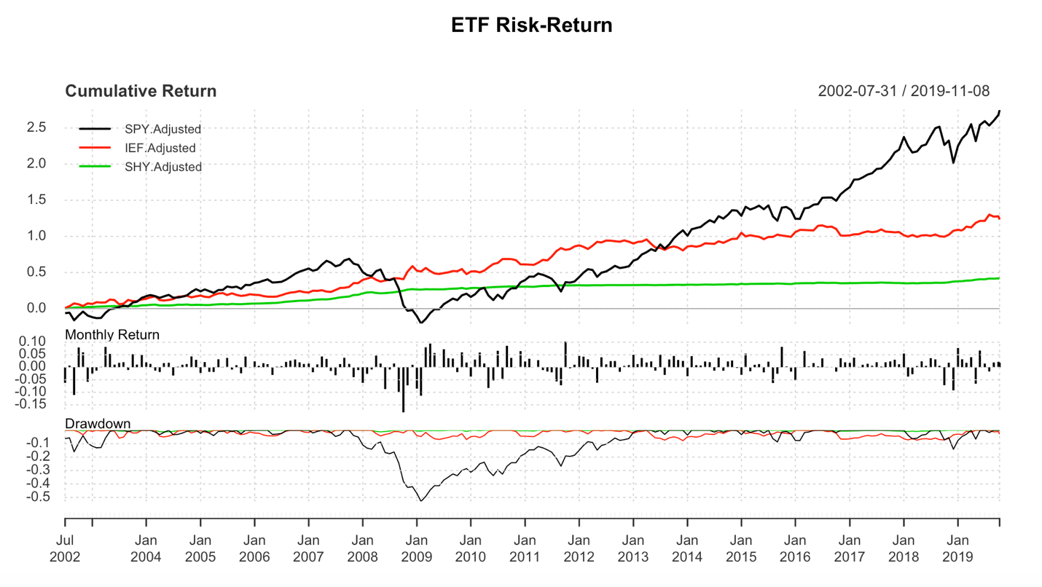



**3.b.** Beta for SPY is 6.292874, for IEF is -1.528488 and for SHY is -0.93706. The SPY has the highest beta, which indicates that the market fluctuations have a strong impact on it and is most exposed to market risk. The IEF and SHY have negative betas, showing that they have a movement in the other direction of the market. Also, SHY has the lowest beta, indicating that it is the least exposed to market volatility.



y1

y4

**Forward Contracts and No-Arbitrage Pricing**

**1.** The fair values for the years 1 to 5 are101.7654, 103.5620, 105.3903, 107.2508 and 109.442.

The graph indicates that the asset price and the forward price should be the same under no arbitrage theory and also the forward price is increasing in a linear way with the number of years to maturity.

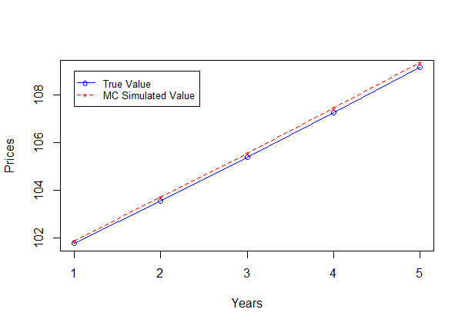

**2.**

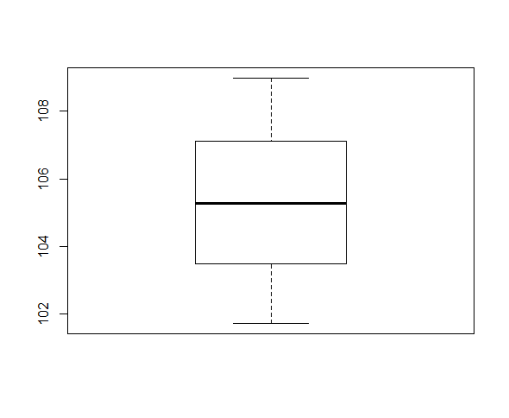

This is the boxplot for the whole 5 years. Based on the boxplot the forward price is 105.2858.

**3.** If we short the forward contract, if the stock price downgrades till maturity, we have hedged the downside risk with the forward contract, so we can sell it at a certain price, which will be higher than the stock price at maturity.

**4.** If the stock price lowers, there is a chance that the forward contract price would increase or decrease. If the forward price gets lower than the stock price, we would long the forward contract so that at maturity we can buy the stocks at a lower price and sell them at the higher price (Short Selling). If the forward price is higher than the stock price, we would short the forward. Hence at maturity, we can sell the stocks at a higher price than the actual stock price.

**5.** When the FED cuts the rates, the investors and the companies will start to invest and spend more. This action causes the stock price to rise.

**Managing Linear Risk**

**1.** We see that the average change is positive and the YEN is getting stronger over time, since the mean of the returns is a positive number.

By plotting the portfolio value, it has a log normal distribution (right skewness). Since the mean of pl is positive, we are expecting to gain money.

Also, the mean of portfolio value and the term q*s0*(exp(theta*tau)-1) have roughly the same value.

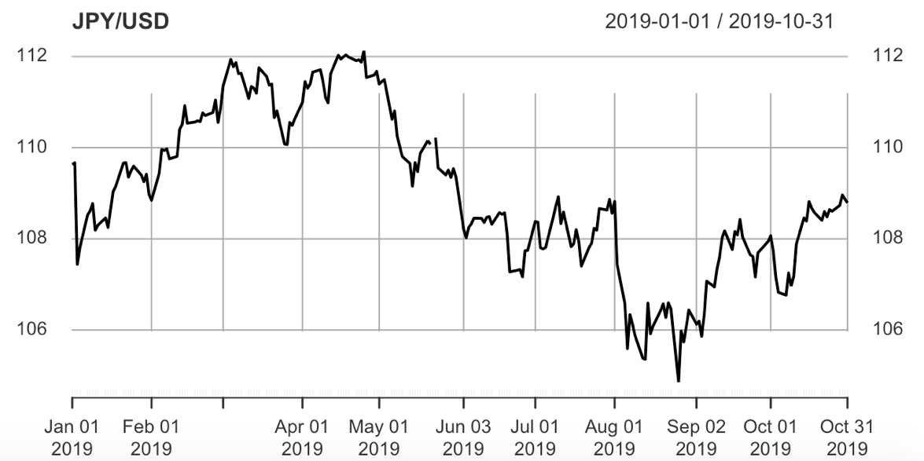



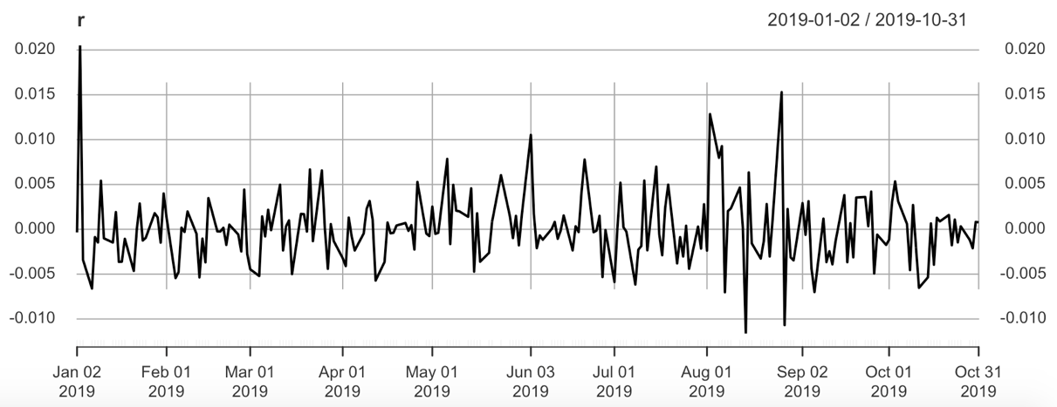

**2.** The VaR value is 107.3918.

**3.** The f0 is fixed but term f1 is random. By entering this future contract, we are able to hedge the downside risk. The VaR value is 0.1952814, which is not quite small. This indicates how much you are going to go below the expectations.

If the future contract expires at September 2020, we have to calculate b1 and b2. As long as b2 is greater than b1, we would have profitability, though b2 is unknown, so it should be simulated. We conclude that b2 is always smaller than b1 (Yen appreciates), as a result by longing the basis, the hedge will cause loss.

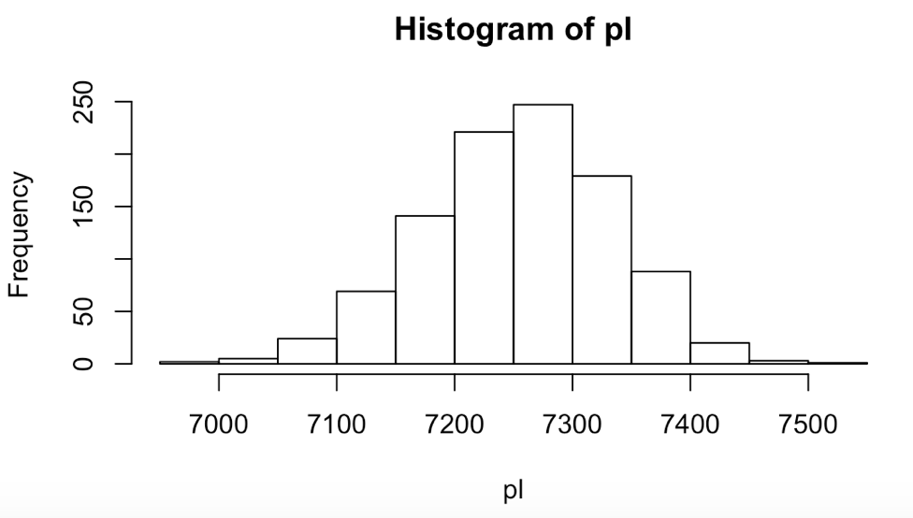

**Hedging using ETFs**

**4.a.** The first thing we need to look at is how are ETFs and Treasury bonds related and how much exposure the interest rate would have on them. Based on interest rate parity, supply and demand impact the interest rate and currency. Also, all bonds are under influence of the interest rates. So the interest rate is the common factor between these two.

If the IEF prices go up, since it is a fixed income index and the higher the yield, the lower the price holds, the interest rates decrease. Hence, we expect USD to depreciate and we get more dollars in exchange of each Yen.

By calculating beta, we get a positive number, which was predictable from the positive correlation. We would short the IEF index, since we have an asset and based on the positive beta, we want to mitigate the loss if the prices drop. By substituting the numbers in the formula for N and taking into account as Qf is 1, we conclude to short 18466470 contracts.

**4.b.** Using ETFs for hedging is called cross-hedging. This is less effective than using a futures contract on the same exchange rate. For effectiveness, we measure R-squared, which is 0.01138. As we can see this value is closer to zero than one showing that hedging with ETFs is not that effective for this currency trade. As in future contracts, we are dealing with the same asset (returns on the futures contract is a linear function of the returns on the underlying asset). Hence, the correlation would be 1, meaning that the effectiveness would be 100%.

**4.c.** ETFs are easily and cheaply traded. Moreover, they are considered safe bonds.Another factor that should be considered is the economic conditions, such as economic stress. As there is a shock to economy, the price for government bonds increase. At this time, the ETFs do not serve as hedging.

**Reference**

[1] <https://www.investopedia.com/stock-analysis/011615/investing-government-bond-etfs-shy-ief-tlt-iei.aspx>

**Appendix**

All the values asked in the questions, if not reported, can be found through the code.